Temporary Deviation – Crompton Road/ Shepstone Road Intersection - To complete a pipe crossing

Dear Valued Citizen

Please be advised of the temporary deviation, which is proposed to be instituted at the Crompton/ Shepstone road intersection in New Germany.

Construction in this area will begin at 07:00 on Saturday, 1st April and will end at 17:00 on Sunday, 2nd April.

A new water pipe will be laid across Crompton Road during this time period.

Motorists will have access to Crompton Road from Shepstone, but the road will be reduced from four lanes to two. One-half of Crompton road will be closed and traffic will be placed on the other half (as shown in the diagram below as part 1). Once work has been completed on the first half, traffic will be placed onto the previously closed area until the whole job is complete (shown as part 2).

Motorists can also access Shepstone road via Cherry Lane if they wish, this route is indicated by the detour signs on the drawings.

Motorists are requested to use the alternative routes on the affected days to avoid delays.

Your patience and understanding will be appreciated.

For information on Go! Durban please visit www.godurban.co.za

Ukuvalwa Komgwaqo Kwesikhana – Ezimpambanweni zomgwaqo uCrompton noQashana Khuzwayo – Ukuqedelela ukufakwa kwepayipi lamanzi elidabula umgwaqo

Sakhamuzi Esihloniphekiyo

Sithanda ukukwazisa ngokuvalwa komgwaqo kwesihashana okubheke ukuba ube sezimpambanweni zomqwaqo kuCrompton noQashana Khuzwayo eNew Germany.

Ukwakhiwa kule ndawo kubhekeke ukuba kuqale ngoMqibelo (Saturday) ngehora lesikhombisa ekuseni (7h00 am) ngomhla ziwu-1 kuMbasa (April 2-17) kuphele ngehora lesihlanu ntambanma (17h00 pm) ngeSonto (Sunday) mhla ziwu-2 kuMbasa 2017 (April)

Kuzobe kufakwa ipayipi elisha lamanzi ngesikhathi kuvalwe umugwaqo.

Abaqhubi bezimoto bazokwazi ukufinyelela kuCrompton, uma besuka kuShepstone, uma besebenzisa uCherry Lane noma sebephinda emuva.
Isithombe esibhaliwe sokuvalwa komgwaqo ungasibheka ngenzansi.
Abashayeli noma abaqhubi bezimoto bayanxuswa ukuba basenzise eminye imigwaqo ukuvimbela ukubambezeleka emugwaqeni ngalesi sikhathi sokuvalwa komgwaqo kwesikhahlana.

Abaqhubi bezimoto bazokwazi ukufinyelela kuCrompton Road uma beqhamuka kuShepstone Road, kodwa umugwaqo uzoncishiswa ube nemizila emibili (two lanes) kusukela kwemine (four lanes). Inxenye yomgwaqo uCrompton izovalwa, izimoto zizosebenzisa enye inxenye yomgwaqo (nje ngoba kukhonjiswa esithombeni esibhaliwe ngenzansi – esigabeni sokuqala). Kuzothi umsebenzi ungaphela enxenyeni yokuqala le ebivaliwe izimoto zizobe sezishintshelwa kule enye inxenye yomgwaqo kuze kube uyaphela umsebenzi.
Abaqhubi bezimoto bazokwazi ukufinyelela kuShepstone Road uma bezosebenzisa uCherry Lane uma befisa kanjalo. Lendlela ikhonjiswe ngezinkomba zomgwaqo (Detour Signs) esithombeni esibhaliwe ngenzansi.

Ukusibekezelela nokuzwelana nathi kuyosithokozisa.

Noma uvakashele uGo! Durban kwi-website ethi www.godurban.co.za

Alternative routes for Saturday/Sunday
Indlela Yesikhashana yangoMqibelo neSonto

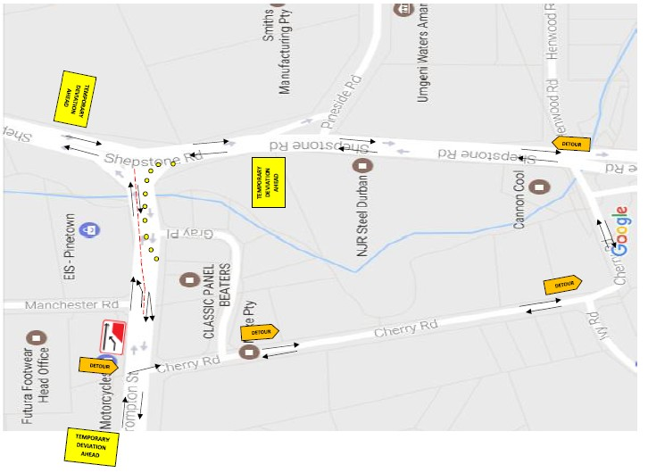

Part 1
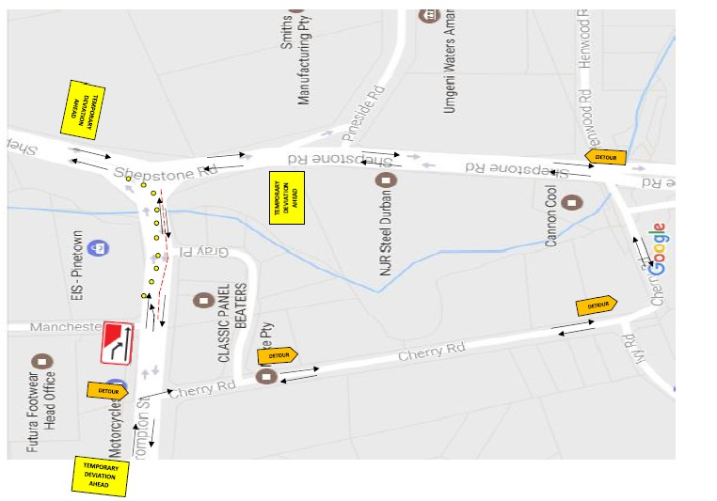

Part 2

