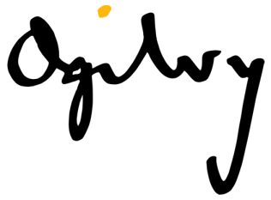
CLIENT ETA
Brand Go! Durban
JOB NO. 28118
DESCRIPTION Quarter 1 - ADVERTORIAL
COPYWRITER Sandhya Mathura
DATE 01/03/2017

ORIGINAL ARTICLE –
Headline: Shaping Durban’s new public transport system
Sub-heading: GO!Durban is making huge strides in transforming our country’s historically divided society.
Body copy: Urban planning during apartheid saw citizens corralled into geographically separated areas which impacts on how they are able to move around for work, community and leisure. Our government recognised that transforming public transport across the country would help address the inequalities of the past. This overhaul will take us further in achieving the City’s vision of making Durban Africa’s most caring and liveable City by 2030.
For the past nine years many cities across South Africa have been adapting their transport systems, in line with international trends. This often includes making provisions for dedicated bus lanes.
Durban spent some time in planning a fully integrated network and began constructing the first route in the first phase of the network in 2014. This first route, known as the C3 Corridor, features a dedicated bus lane from Pinetown CBD to Bridge City in KwaMashu. The second route is the C9 Corridor which links to the C3 at Bridge City. The C9 runs from Bridge City via Phoenix Industrial through Cornubia to Umhlanga New Town Centre near Gateway Theatre of Shopping.
Construction began on the C9 in 2016 on the bridge over the N2 just north of the impressive multi-layered Mount Edgecombe/ Umhlanga interchange. This will accommodate the dedicated bus lane that will eventually come from KwaMashu on the C9 route.
Despite the challenges such as weather, security and labour issues and of course the challenge of constructing in existing mixed-use traffic, we can offer good news. Most of the major construction on the first route is almost complete. People have already begun to feel the ease of traffic flow on these roads.
Infrastructure development:
- The first bus station at Regent Street/ Qashana Khuzwayo Road intersection will be completed this year. This station sets the benchmark for the next five stations to be built along this route.
- Most of the work that affects the flow of traffic on Anderson and Josiah Gumede Roads is now complete, with only finishing work remaining.
- From Beviss along Qashana Khuzwayo Roads much of the construction has been completed. Sections from Suffert to Horton Street, St Johns to Cherry Road, Pineside to Broadway and Broadway to Otto Volek will still be under construction for the next few months.
- Works between Cherry and Broadway Roads will impact on traffic flow, pedestrian flow and parking in the meanwhile.
- In the next few months, construction will begin of the top structures of the four stations at Moodie Street, Josiah Gumede (outside the Pinetown Library), Beviss / Josiah Gumede intersection and the Qashana Khuzwayo/ Henwood Road intersection. This will not affect the traffic as work takes place within the closed dedicated bus lanes. The completion date for this work is the last quarter of 2017.
- The road works between Umgeni Bridge and the Avoca Hills intersection has been completed and all general traffic lanes are now open. Works will continue on the roadway from Avoca Hills Intersection to the M25 on-ramp until April/ May 2017 which may affect traffic.
- Construction work will continue on the new bus lanes along MR577 and this will give rise to some works at Newlands and Malandela Intersections which may affect general traffic over a couple of weekends.
- Lane construction along the M25 westbound from MR577 to the Bhejane Underpass has been completed including the M25 Underpass and traffic has returned to normal. Work is still being undertaken on the median but this will not affect traffic.
- The M25 off-ramp to Bhejane Road will reopen along with a new on-ramp onto the M25 Eastbound.
- Exciting news is that the re-development of the Crossroads commercial and transport node in Phoenix/ KwaMashu is due to begin shortly. The completion of the bus rapid transit lane and the pedestrian underpass at the Malandela intersection forms part of this re-development. Construction of the dedicated bus lanes and station here is expected to start in the second half of this year. This redevelopment will go a long way to stimulate the local economy and thriving commercial hub that already exists here.
- Construction at the basement area of Bridge City is expected to be complete in the first half of 2018. This will house the bus terminal that will link the commuters on trains from KwaMashu to the City, and on buses to Pinetown CBD and Umhlanga Newtown.
- 2017 Is the year of delivery for a vital component in the C9 corridor of GO!Durban. The Cornubia bridge and interchange, which sits astride the N2, links Umhlanga Ridge through the Cornubia development to Bridge City in KwaMashu and onto Pinetown’s CBD.
- Completion of this project is scheduled for the last quarter of 2017 and will coincide with the opening of Cornubia Shopping Centre.
- The fast tracking of Cornubia bridge and interchange has saved the City approximately R180 million, as it falls within the current contract for the Mount Edgecombe Interchange construction.

TEXT BLOCK: To report any snags as a result of construction, please contact the GO!Durban call centre on: 080 131 3013 to have the situation assessed.

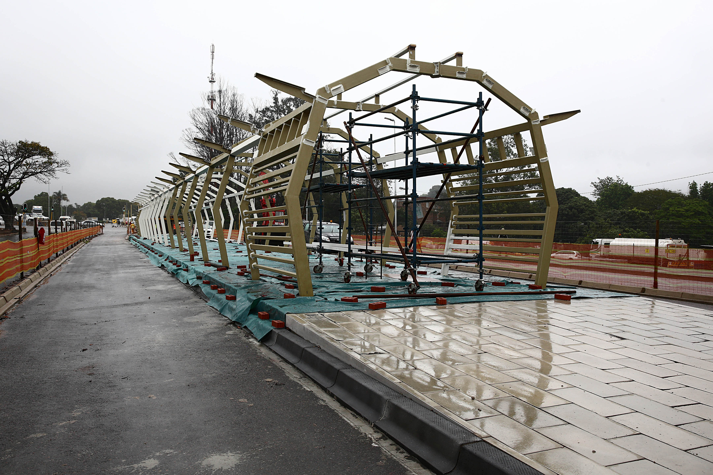
At the Regent Street Station the structure is now clearly visible
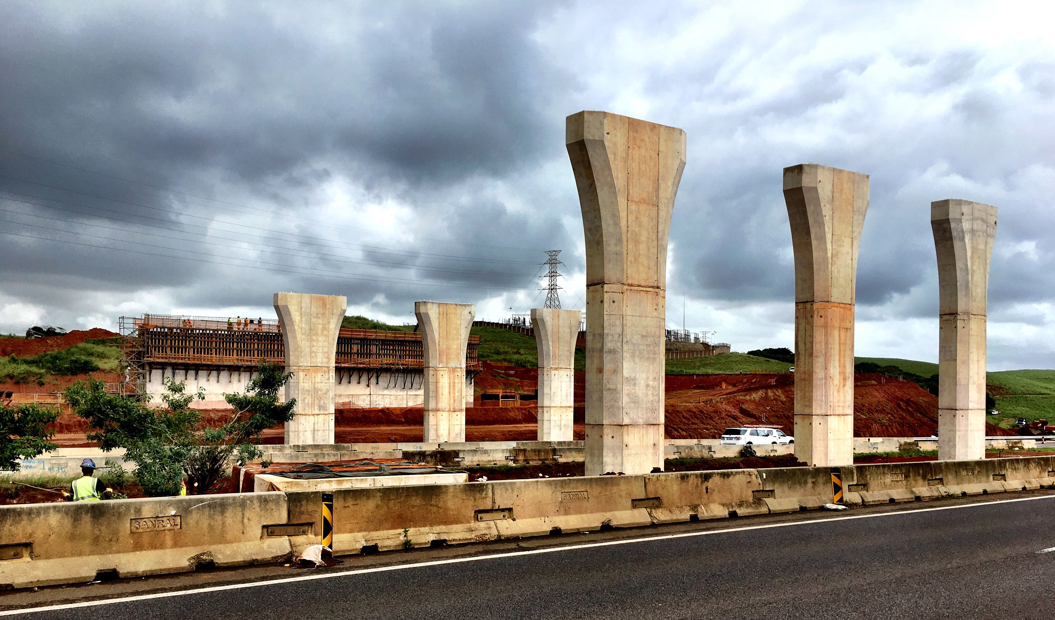
The bridge piers at the Cornubia interchange, on the C9, rise impressively into the sky, with the Western Abutment behind.
EDITED/ SUMMARISED ARTICLE

Headline: Enhancing Durban’s Commuter Experience
Body copy: Apartheid urban planning forced citizens into physically separated areas. This made commuting for work and leisure a difficult and inequitable process. Our government recognised that transforming public transport across the country would help address the inequalities of the past. This overhaul will take us further in achieving the City’s vision of making Durban Africa’s most caring and liveable City by 2030.
For the past nine years many cities across South Africa have been adapting their transport systems, in line with international trends. This often includes making provisions for dedicated bus lanes.
Durban has been planning a fully integrated network for some time. Construction of the first route, in the first phase of the network, began in 2014. This first route, known as the C3 Corridor, features a dedicated bus lane from Pinetown CBD to Bridge City in KwaMashu. The second route is the C9 Corridor which links to the C3 at Bridge City. The C9 runs from Bridge City via Phoenix Industrial through Cornubia to Umhlanga New Town Centre near Gateway Theatre of Shopping.
Construction began on the C9 in 2016 on the bridge over the N2 just north of the Mount Edgecombe/ Umhlanga interchange. This will accommodate the dedicated bus lane that will eventually come from KwaMashu on the C9 route.
Despite various challenges, most of the major construction on the first route is almost complete. People have already begun to feel the ease of traffic flow on these roads.
Infrastructure development:
- The first bus station at Regent Street/ Qashana Khuzwayo Road intersection will be completed this year.
- Most of the work on Anderson and Josiah Gumede Roads is now complete.
- From Beviss along Qashana Khuzwayo Roads much of the construction has been completed. Sections from Suffert to Horton Street, St Johns to Cherry Road, Pineside to Broadway and Broadway to Otto Volek will still be under construction for the next few months.
- Works between Cherry and Broadway Roads will impact on traffic flow, pedestrian flow and parking in the meanwhile.
- In the next few months, construction will begin of the top structures of the four stations at Moodie Street, Josiah Gumede (outside the Pinetown Library), Beviss / Josiah Gumede intersection and the Qashana Khuzwayo/ Henwood Road intersection. This will not affect the traffic as work takes place within the closed dedicated bus lanes. The completion date for this work is the last quarter of 2017.
- The road works between Umgeni Bridge and the Avoca Hills intersection has been completed and all general traffic lanes are now open. Works will continue on the roadway from Avoca Hills Intersection to the M25 on-ramp until April/ May 2017 which may affect traffic.
- Construction work will continue on the new bus lanes along MR577 and this will give rise to some works at Newlands and Malandela Intersections.
- Lane construction along the M25 westbound from MR577 to the Bhejane Underpass has been completed including the M25 Underpass and traffic has returned to normal.
- The M25 off-ramp to Bhejane Road will reopen along with a new on-ramp onto the M25 Eastbound.
- The re-development of the Crossroads business and transport node in Phoenix/ KwaMashu is due to begin shortly. The completion of the bus rapid transit lane and the pedestrian underpass at the Malandela intersection forms part of this re-development. Construction of the dedicated bus lanes and station here is expected to start in the second half of this year.
- Construction at the basement area of Bridge City is expected to be complete in the first half of 2018. This will house the bus terminal that will link the commuters on trains from KwaMashu to the City, and on buses to Pinetown CBD and Umhlanga Newtown.
- 2017 Is the year of delivery for the Cornubia bridge and interchange.
- Completion of this project is scheduled for the last quarter of 2017 and will coincide with the opening of Cornubia Shopping Centre.

TEXT BLOCK: To report any snags as a result of construction, please contact the GO!Durban call centre on: 080 131 3013 to have the situation assessed.

At the Regent Street Station the structure is now clearly visible
The bridge piers at the Cornubia interchange, on the C9, rise impressively into the sky, with the Western Abutment behind.

